**Deliverable 3 Part 2**

* **Product Backlog Update**

There were a few minor changes with the user stories, where we added a bit more detail to each of them. The user stories, we had earlier didn’t seem to have enough details and were very vague, so we changed them to give it more detailed.

**Updated Version:**

**John**

1) I John, a researcher, want the program to extract information about exoplanets and their systems from the other catalogues (NASA and exoplant.eu) and convert them into the structure of the OEC so they can be added to the OEC.

2) I john, a researcher, want the program to determine if an exoplanet/system is new and needs to be added or already exists and can be updated/merged in the OEC.

3) I John, a researcher, want to be able to manually update the catalogue by running the program through the command line, by calling a command on a terminal to initiate the updating/merging process.

4) I John, a researcher, want to be shown all new additions and changes made to pre-existing entries in the OEC when manually merging with other catalogues.

The planets/systems that were added should be listed, as well as the old and new values for any field/value of a pre-existing planet/system that was updated.

5) I John, a researcher, want to be able to resolve individual conflicts when merging, by being shown the two versions and being prompted (in the terminal) to choose which version of the conflict to merge into the OEC.

6) I John, a researcher, want to be able to configure how often (in days) the program runs automatically to attempt to merge/update the OEC.

7) I John, a researcher, want to be notified by email of conflicts when an automatic merge occurs, so I can manually go in and choose which conflicts to merge.

8) I John, a researcher, want to get a report by email after an automatic merge, containing the changes and additions made to the OEC. It should list all the planets and their systems that were added and updated. It should also list what was changed for planets/systems that were updated.

9) I John, a researcher, want the git repository to be updated with a successful merged catalogue, by pushing the updated catalogue onto the repo, so that I have a log of all merges/changes made to the OEC.

10) I John, a researcher, want the new changes when merging to match the units and format of the OEC.

**Alice**

1) I Alice, a professor, want the application to regularly run automatically so that the catalogue can stay up to date.

2) I Alice, a professor, want the merge to automatically solve any conflicts and apply the changes without my input by either choosing my conflict or their conflict for every conflict.

**Overview**

We progressed a lot compared to Deliverable 2, we did end up changing a few user stories as mentioned above, because they needed some more details, so that was a major change from deliverable 2 to deliverable 3.

For this sprint, we had estimated the project velocity of 14 points, we had planned that we will cover user story 1(worth 8 points) and 3(worth 4 points). The sprint that we planned was only supposed to be a week. We underestimated the cost of some of our tasks, however with the efforts of the team and the work we all put in, we were able to achieve our estimated project velocity and did cover all 14 story points, thus our actual project velocity after deliverable 3 is 14 points. We did not have any re-planning stages, we decided at the start of our sprint the user stories we will be able to fully implement, and distributed the work according to that. In the future we will better estimate the cost of tasks and reassign costs for user stories to more accurately estimate their cost.

**Burndown Chart:**

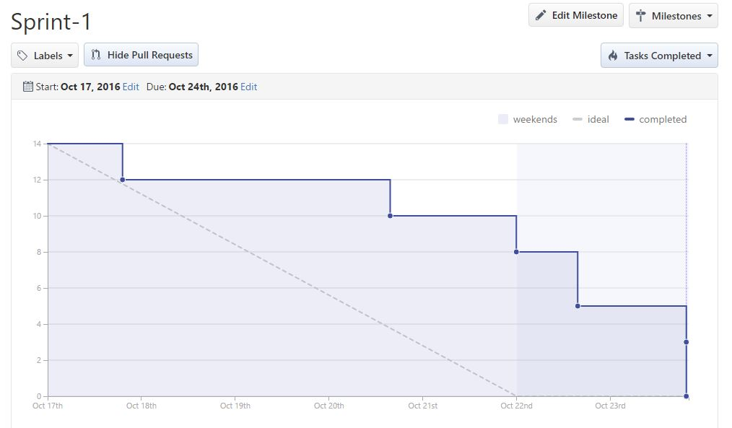

**Task Board:**

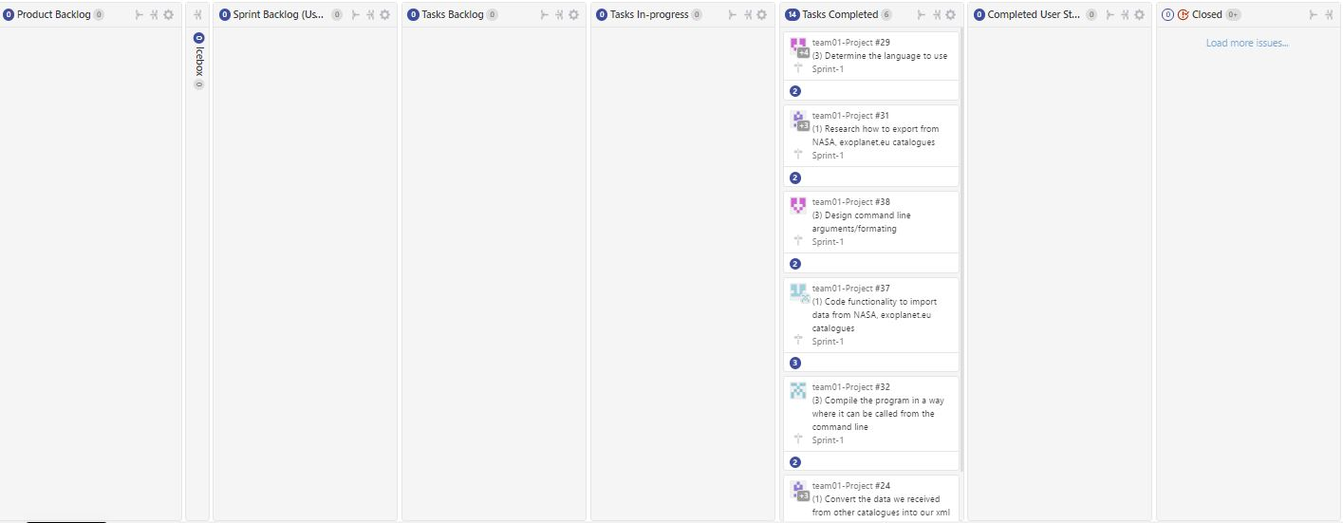

This is how our task board and our burndown chart looks for sprint 1, we were able to complete all the tasks for this sprint on time. There is a bit of a twist with the burndown chart, and that is it only records the planned line up and until the weekdays and over the weekend the planned line goes to 0. So from the chart we can see that the team made a bit of progress over the weekdays and we made a lot of progress over the weekend which is when we were able to complete our tasks, we did have a little bit of a break from the project because of focus on the midterms and other courses, but we were able to catch up and finish the sprint at the due date.